**Step 1: Drawing Basic Shapes With Python Turtle**

1. Create an new Repl by selecting the **“Python with Turtle”** language / environment.

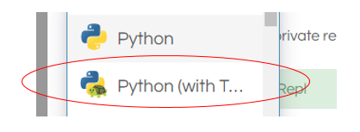

1. Begin all of your turtle programs with the following code to create a “pen”:

import turtle

myPen = turtle.Turtle()

1. Review the following chart for a list of Turtle commands.

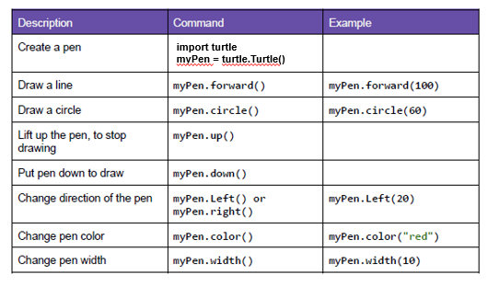

1. Use the following program to draw a red square.

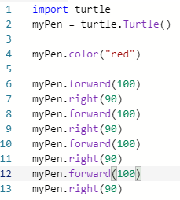

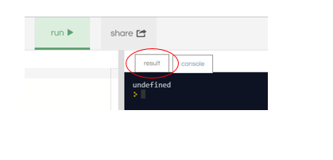

1. Switch to the “Result” window to see the square.
2. Create a program to draw any one of the shapes “b”, ”d”, or “e” shown in the figures below.   
   Provide a listing of your program code.

import turtle

myPen = turtle.Turtle()

myPen.color("red")

myPen.forward(100)

myPen.right(90)

myPen.forward(50)

myPen.right(90)

myPen.forward(100)

myPen.right(270)

myPen.forward(100)

myPen.right(90)

myPen.forward(50)

myPen.right(90)

myPen.forward(100)

myPen.right(270)

myPen.forward(100)

myPen.right(90)

myPen.forward(50)

myPen.right(90)

myPen.forward(100)

myPen.right(270)

myPen.forward(100)

myPen.right(90)

myPen.forward(50)

myPen.right(90)

myPen.forward(100)

myPen.right(270)

1. Create a program to draw any one of the shapes “c”, or “f” shown in the figures below.   
   Provide a listing of your program code.

import turtle

myPen = turtle.Turtle()

myPen.color("red")

myPen.forward(100)

myPen.right(90)

myPen.forward(100)

myPen.right(90)

myPen.forward(100)

myPen.right(90)

myPen.forward(100)

myPen.right(180)

myPen.up

myPen.left(360)

myPen.forward(50)

myPen.down

myPen.color("blue")

myPen.circle(50)

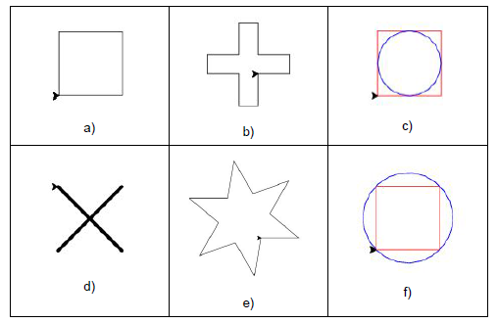

**Step 2: Christmas / Winter Theme Card**

1. Use your creativity to create a card design using Turtle.
   1. The design must have multiple figures.
   2. The design must have at least two different patterns.
   3. You may repeat patterns.
   4. Provide a listing of your program code.
   5. Provide an image of your program result.

import turtle

myPen = turtle.Turtle()

myPen.color("black")

myPen.speed(40)

#This will make the box

myPen.forward(500)

myPen.right(90)

myPen.forward(500)

myPen.right(90)

myPen.forward(500)

myPen.right(90)

myPen.forward(500)

myPen.fillcolor('light blue')

myPen.begin_fill()

myPen.right(90)

myPen.forward(500)

myPen.right(90)

myPen.forward(500)

myPen.right(90)

myPen.forward(500)

myPen.right(90)

myPen.forward(500)

myPen.end_fill()

myPen.up()

myPen.right(90)

myPen.forward(250)

myPen.right(90)

myPen.forward(400)

myPen.down()

myPen.color("green")

myPen.right(90)

myPen.forward(250)

myPen.right(180)

myPen.forward(500)

#This will make the grass

myPen.fillcolor('green')

myPen.begin_fill()

myPen.right(90)

myPen.forward(100)

myPen.right(90)

myPen.forward(500)

myPen.right(90)

myPen.forward(100)

myPen.right(90)

myPen.forward(500)

myPen.end_fill()

#This will make the snowman

myPen.right(180)

myPen.forward(250)

myPen.right(180)

myPen.color("grey")

myPen.fillcolor("white")

myPen.begin_fill()

myPen.circle(75,540)

myPen.end_fill()

myPen.right(180)

myPen.fillcolor("white")

myPen.begin_fill()

myPen.circle(55,540)

myPen.end_fill()

myPen.right(180)

myPen.fillcolor("white")

myPen.begin_fill()

myPen.circle(40,540)

myPen.end_fill()

myPen.right(180)

#Time to work on the face

myPen.up()

myPen.right(90)

myPen.forward(50)

myPen.down()

myPen.color("orange")

myPen.fillcolor("Orange")

myPen.right(270)

myPen.begin_fill()

for i in range(1):

myPen.forward(80)

myPen.left(175)

myPen.forward(80)

myPen.left(90)

myPen.forward(8)

myPen.left(90)

myPen.right(2)

myPen.end_fill()

myPen.up()

myPen.left(90)

myPen.forward(15)

myPen.left(90)

myPen.forward(20)

myPen.down()

myPen.color("grey")

myPen.fillcolor("Black")

myPen.begin_fill()

myPen.circle(5,540)

myPen.end_fill()

myPen.up()

myPen.forward(40)

myPen.left(100)

myPen.forward(20)

myPen.down()

myPen.color("grey")

myPen.fillcolor("Black")

myPen.begin_fill()

myPen.circle(5,540)

myPen.end_fill()

myPen.up()

myPen.forward(100)

myPen.left(270)

myPen.forward(18)

myPen.left(90)

myPen.forward(25)

myPen.down()

myPen.color("grey")

myPen.fillcolor("Black")

myPen.begin_fill()

myPen.circle(5,540)

myPen.end_fill()

myPen.up()

myPen.forward(25)

myPen.down()

myPen.color("grey")

myPen.fillcolor("Black")

myPen.begin_fill()

myPen.circle(5,540)

myPen.end_fill()

myPen.up()

myPen.left(155)

myPen.forward(25)

myPen.down()

myPen.color("grey")

myPen.fillcolor("Black")

myPen.begin_fill()

myPen.circle(5,540)

myPen.end_fill()

#Time to make the hands

myPen.up()

myPen.forward(25)

myPen.right(45)

myPen.forward(45)

myPen.down()

myPen.fillcolor("Brown")

myPen.begin_fill()

for i in range(1):

myPen.forward(80)

myPen.left(175)

myPen.forward(80)

myPen.left(90)

myPen.forward(8)

myPen.left(90)

myPen.right(2)

myPen.end_fill()

myPen.up()

myPen.right(180)

myPen.forward(105)

myPen.down()

myPen.fillcolor("Brown")

myPen.begin_fill()

for i in range(1):

myPen.forward(80)

myPen.left(175)

myPen.forward(80)

myPen.left(90)

myPen.forward(8)

myPen.left(90)

myPen.right(2)

myPen.end_fill()

#time to write the text

myPen.color('Red')

def write_message(turtle, color, x, y):

turtle.penup()

turtle.goto(x,y)

turtle.pendown()

turtle.pensize(30)

turtle.color(color)

turtle.write("Feliz Navidad!", None, None, "48pt bold")

write_message(turtle, "red", 65,-150)